Lubbock County Bail Bond Companies

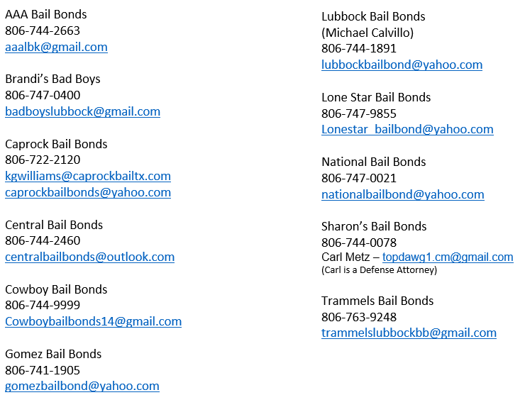

Freedom Bail Bonds- Amarillo
806-374-0333
bailbondfreedom@gmail.com

